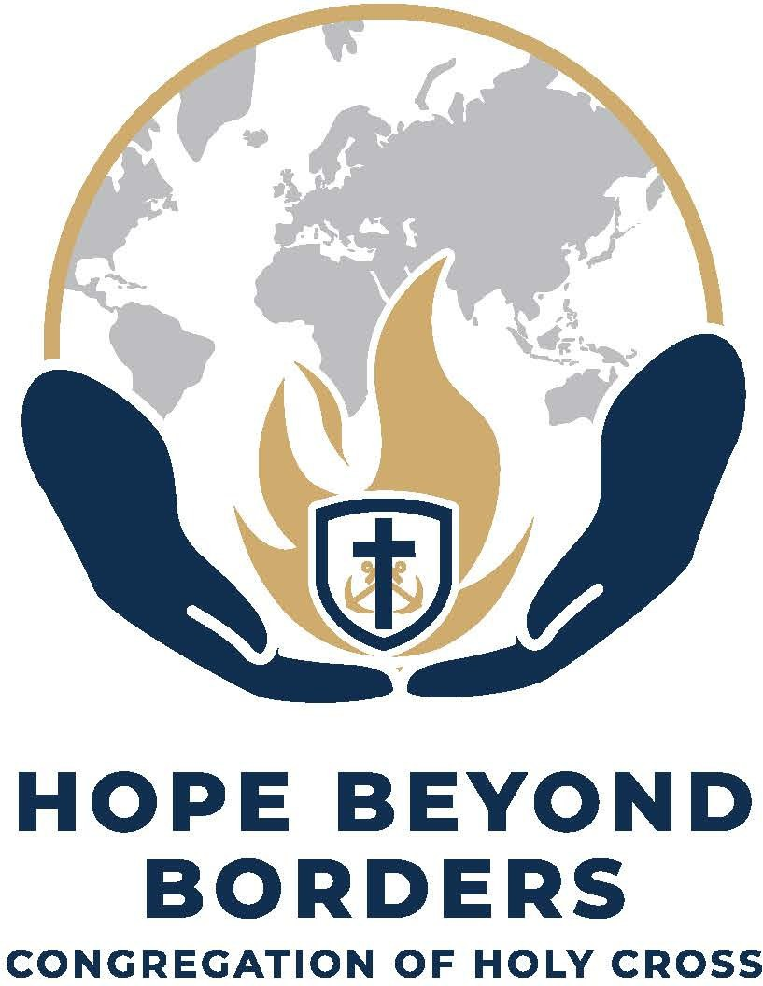

YEAR OF MISSION WORSHIP BOOKLET
APRIL 28, 2025—APRIL 28, 2026

TABLE OF CONTENTS
A Few Words About This Worship Booklet | Pg. 3
Morning Prayer on April 28, 2025 | Pg. 4
Morning Prayer on April 28, 2026 | Pg. 11
About Our Co—Patrons: Brother Flavian LaPlante and Bishop Vincent McCauley | Pg. 17—18

A Few Words About this Worship Booklet
In the year 1840, Blessed Basile Moreau, the founder of the Congregation of Holy Cross, sent Brother André Mottais, Brother Alphonsus Rodriguez Tulou, novice Brother Ignace Feron, Father Le Boucher and Father Victor Drouelle to Algiers, the Congregation’s first-ever overseas mission. To mark the 185th Anniversary of their sending, and to celebrate the sending of 8 of our Holy Cross missionaries (4 Brothers and 4 Priests from 7 Jurisdictions and 5 countries) to the Holy Family Mission in the Diocese of Bougainville in Papua New Guinea (PNG), our Superior General, Br. Paul Bednarczyk, C.S.C., announced a Year of Mission with the theme, Hope Beyond Borders, for celebration by the whole family of Holy Cross.
To facilitate this celebration, the General Council created a task force to provide resources for use during this Year of Mission. This booklet is one such resource. It offers Morning Prayer and Evening Prayer for both the opening (April 28, 2025) and the closing (April 28, 2026) celebrations for the Year of Mission. Please feel free to adapt it to your needs and circumstances.
May the Co-Patrons of this Year of Mission, Servants of God Flavian Laplante and Vincent McCauley, intercede for us all.
Have a fruitful and blessed Year of Mission!
Members of the Task Force
The Year of Mission
April 2025
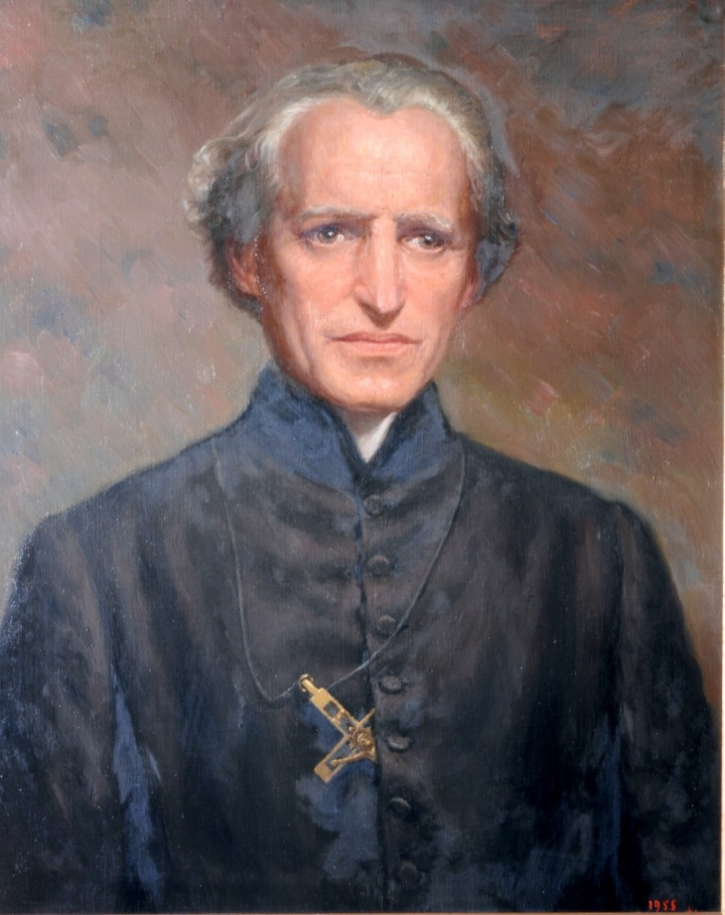
Blessed Basil Anthony Mary Moreau, Founder Congregation of Holy Cross

MORNING PRAYER
April 28, 2025
Verse and Response
Leader: In the Name of the Father, and of the Son, and of the Holy Spirit. Amen

Leader: God, + come to my assistance.
All: Lord, make haste to help me.

Leader: Glory to the Father, and to the Son, and to the Holy Spirit:
All: as it was in the beginning, is now, and will be for ever. Amen. Alleluia.
Hymn | This Day God Gives Me
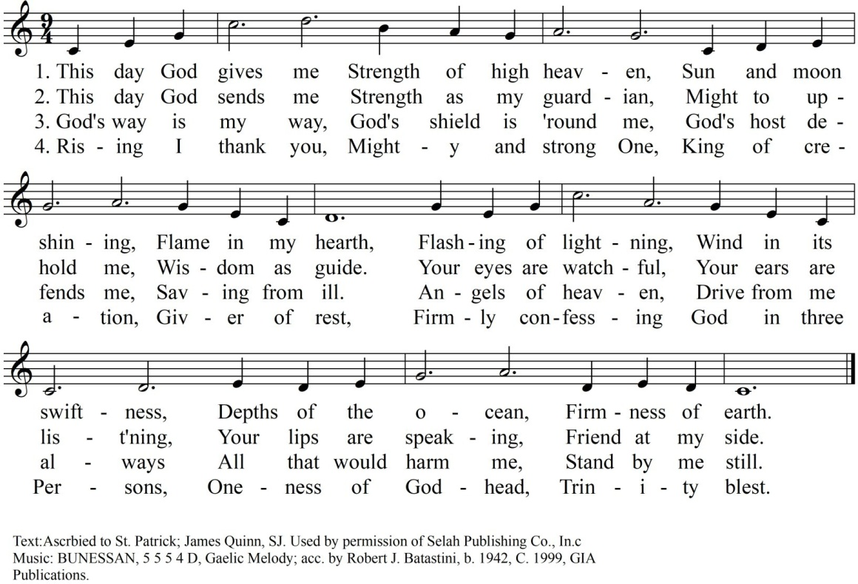

Introduction
Leader: Today we celebrate the 185th Anniversary of Blessed Basile Moreau sending the first Holy Cross men beyond the borders of France in 1840. We also begin today a Year of Mission, during which the whole Family of Holy Cross will reflect on our purpose, seek to renew our zeal, and ask how we might revitalize our charism in light of the Church’s and society’s current needs. This is a time for reflecting on how we can be people “with hope to bring” to a world in which the light of hope is in danger of being extinguished for so many of our brothers and sisters. During this special year set aside for discernment, we are called to renew our pledge to join in deeper solidarity with “men and women of grace and goodwill everywhere in their ef- forts to form communities of the coming Kingdom.” As part of the larger family of Holy Cross let us offer our Morning Prayer for God’s blessings on all.
Opening Prayer
Leader: O God, you inspired Blessed Basile Moreau with a vision of making You known, loved, and served in ministries of education, parish, and social outreach throughout the world. As we share in the inauguration of the Year of Mission with its theme of Hope Beyond Borders, may we commit ourselves to furthering the work of Resurrection as envisioned by Blessed Moreau. Stir up, we pray, the hearts of us all that we may be bearers and witnesses of hope to the world. We ask this through Christ our Lord. Amen.

Psalmody
Psalm 119:1-4, 9-14, 103-104
Leader: Those who teach justice to many will shine like the stars for all eternity.
Leader:  Blessed those whose way is blameless, who walk by the law of the Lord.  Blessed those who keep his testimonies, who seek him with all their heart.  How can the young keep his way without fault? Only by observing your words.  With all my heart I seek you;  do not let me stray from your commandments.  With my lips I recite  all the judgments you have spoken.  I find joy in the way of your testimonies more than in all riches. | All:  They do no wrong;  they walk in his ways.  You have given them the command to observe your precepts with care.  In my heart I treasure your promise, that I may not sin against you.  Blessed are you, O LORD;  teach me your statutes.  How sweet to my tongue is your promise, sweeter than honey to my mouth!  Through your precepts I gain understanding; therefore I hate all false ways.

All: | Glory to the Father, and to the Son, and to the Holy Spirit:  as it was in the beginning, is now, and will be for ever. Amen.  Those who teach justice to many will shine like the stars for all eternity.

Reading | Writings of Father Moreau
If I could have foreseen the development of the Congregation of Holy Cross from the outset, I could then have regulated and coordinated everything in advance. If such were the case, however, the Congregation would have been a merely human combination and not the work of Divine Providence. The fact of the matter is that it began and developed in a manner so mysterious, that I can claim for myself neither credit for its foundation nor merit for its progress. Therein lies the indubitable proof that God alone is the Founder of this Congregation, since, according to St. Augustine, when we cannot find the cause of a good work, we must recognize that the Lord is its beginning and author. (CL 94-1858)

Intercessions
At the beginning of this Year of Mission, may the Congregation renew its commitment to cross borders of every sort to hasten the coming of the Kingdom.
—Lord, be our light and our hope.
May the members of Holy Cross imitate the heroic work of our predecessors in promoting education, development, and advocacy for human rights throughout the world.
—Lord, be our light and our hope.
May our students, teachers and staff, parents and guardians, sponsors and benefactors experience the joy of sharing Blessed Basil Moreau’s vision of education.
—Lord, be our light and our hope.
May the faculty and staff of this institution succeed in instilling in their students the desire for a better world for all and the hope needed to accomplish it.
—Lord, be our light and our hope.
May the Holy Spirit set on fire the hearts of all associated with the educational ministries of the Con- gregation of Holy Cross, that they may have a burning desire to make the Good News known every- where, despite the obstacles that confront them.
—Lord, be our light and our hope.

Leader: | Let us pray to the Father in the words our Savior taught us: Our Father who art in heaven,  hallowed be thy name. Thy kingdom come.  Thy will be done on earth, as it is in heaven.
All: | Give us this day our daily bread, and forgive us our trespasses,  as we forgive those who trespass against us, and lead us not into temptation,  but deliver us from evil.

Leader: | Let us pray:
All: | Lord God, source of all goodness, in your divine Providence  You entrusted Blessed Basile Moreau with the task of sending missionaries to spread the light of truth  in response to the needs of your universal Church.  We thank you for those faith-filled religious  who risked going beyond the borders of every sort  to proclaim the good news of the kingdom of God.  Enkindle in us all,  members of the Family of Holy Cross, a renewed missionary zeal.  Grant that we may sow the seeds of faith and be heralds of hope to all peoples, especially among the poor,  the oppressed, and the marginalized,  that you may be known, loved, and served.  Through the intercession of  Servants of God Flavian Laplante and Vincent McCauley, give us the grace to respond  generously and wholeheartedly  to the urgent call of evangelization.  We make this prayer in the name of Jesus the Lord. Amen.

Dismissal
Leader: May the Lord bless us, protect us from all evil and bring us to everlasting life.
All: Amen.

Hymn | Let Us Be People of Hope
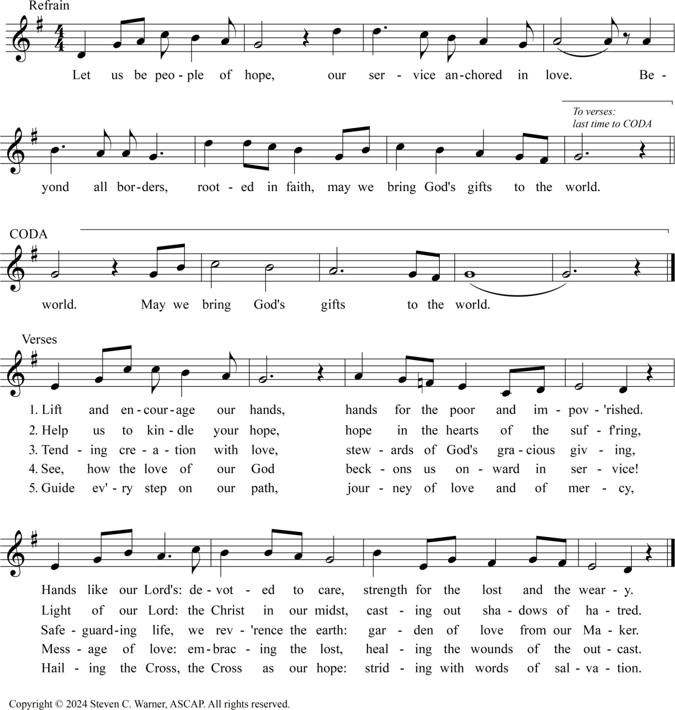

THE CLOSING DAY OF THE YEAR OF MISSION

MORNING PRAYER
April 28, 2026
Verse and Response
Leader: In the Name of the Father, and of the Son, and of the Holy Spirit. Amen

Leader: God, + come to my assistance.
All: Lord, make haste to help me.

Leader: Glory to the Father, and to the Son, and to the Holy Spirit:
All: as it was in the beginning, is now, and will be for ever. Amen. Alleluia.
Hymn | This Day God Gives Me

Introduction
Leader: Today we mark the closing of the Year of Mission that began one year ago. We have spent the last year discussing, reimagining, and rededicating the Congregation to our Founder’s vision of making God known, loved, and served in ministries of education, parish, and mission throughout the world. As I look out at all the young faces here, I am reminded of Blessed Moreau’s words, “Hurry then; take up this work of resurrection, never forgetting that the special end of the Institute is, before all, to make young people holy. It is by this that you will contribute to preparing the world for better times than ours.” Father Moreau believed that the seeds of that new life would be planted through schools that assured an education and a formation to values that could change society; through parishes that would refresh the spiritual life of the people; and through a variety of services to meet the pressing needs of so many who had been neglected.

Our founder wanted all of us, young and old, to be people who recognize the almost limitless potential of the goodness within humanity, people who believe that each person and the world can be transformed. This belief is born of the conviction that God has been and is guiding all that we do. This past Year of Mission has taught us to be people of hope regardless of what we experience and what we observe happening in the world today. It is a choice we make in our studies, in our work, and in how we live. As we go forward let us be filled with zeal to be bearers and witnessed of hope. Let us offer our Morning Prayer for all who are most in need of the gift of hope today.
Opening Prayer
Leader: O God and Father of us all, we thank you for the opportunity we have had to celebrate the Year of Mission along with all those associated with the Congregation of Holy Cross throughout the world. May the vision of Blessed Basile Moreau to make You known, loved, and served be realized in us and in the world. As we conclude the Year of Mission with its theme of Hope Beyond Borders, stir up, we pray, the zeal to continue to be bearers and witnesses of hope to our broken, bruised, and divided world. We make this prayer through Christ our Lord. Amen.

Psalmody
Psalm 33:13-22
Leader: How beautiful are the feet of those who bring the good news!
Leader:  From heaven the Lord looks down and observes the children of Adam,  A king is not saved by a great army,  nor a warrior delivered by great strength. Useless is the horse for safety;  despite its great strength, it cannot be saved  Our soul waits for the Lord, He is our help and shield.  For in Him our hearts rejoice; in His holy name we trust. | All:  From his dwelling place he surveys  all who dwell on earth.  The One who fashioned together their hearts is the One who knows all their works.  Behold, the eye of the Lord is upon those who fear him, upon those who count on his mercy,  To deliver their soul from death,  and to keep them alive through famine.  May your mercy, Lord, be upon us; as we put our hope in you.

All: | Glory to the Father, and to the Son, and to the Holy Spirit:  as it was in the beginning, is now,  and will be for ever. Amen.  How beautiful are the feet of those who bring the good news!

Reading | Writings of Father Moreau
What is true of a palace whose foundations have been laid, and which is rising gradually until completion is verified, likewise, in a great work of charity. It is not one alone who builds; nor is it one stone, or one single beam of wood that forms it. Each worker contributes something from his own trade; each stone is cut to fit into its one appointed place; and each piece of wood is arranged and placed so as to enhance the general effect of the entire building. Union, then, is a powerful lever with which we could move, direct, and sanctify the whole world, if the spirit of evil, who has been allowed to exercise his power over this earth does not set himself up against
the wondrous effects of this moral force. (CL 5 – 1841)

Intercessions
At the close of the Year of Mission, we give thanks to God for guiding the varied ministries of the Congregation of Holy Cross as they continue to bring hope to all who yearn for a better world.
—Source of all life, raise us to new life
May the Spirit continue to grant all who partner with the missionary efforts of the Congregation of Holy Cross a passionate desire to share the Good News with those hungry for God.
—Source of all life, raise us to new life.
May our students, parents, faculty and staff, and sponsors and benefactors be channels of hope and peace for the world.
—Source of all life, raise us to new life.
May all passing through the portal of this institution continue to be filled with the spirit of Blessed
Basil Moreau, especially his dedication to the transformational possibilities of an educational system that trains both minds and hearts.
—Source of all life, raise us to new life.
May our former students cherish the memory of their time in this institution and pass on the values they learned from the Congregation of Holy Cross to the people they serve.
—Source of all life, raise us to new life.

Leader: | Let us pray to the Father in the words our Savior taught us:  Our Father who art in heaven, hallowed be thy name.  Thy kingdom come.  Thy will be done on earth, as it is in heaven.
All: | Give us this day our daily bread, and forgive us our trespasses,  as we forgive those who trespass against us, and lead us not into temptation,  but deliver us from evil.

Leader: | Let us pray:
All: | Lord God, source of all goodness, in your divine Providence  You entrusted Blessed Basile Moreau with the task of sending missionaries to spread the light of truth  in response to the needs of your universal Church.  We thank you for those faith-filled religious  who risked going beyond the borders of every sort  to proclaim the good news of the kingdom of God.  Enkindle in us all,  members of the Family of Holy Cross, a renewed missionary zeal.  Grant that we may sow the seeds of faith and be heralds of hope to all peoples, especially among the poor,  the oppressed, and the marginalized,  that you may be known, loved, and served.  Through the intercession of  Servants of God Flavian Laplante and Vincent McCauley, give us the grace to respond  generously and wholeheartedly  to the urgent call of evangelization.  We make this prayer in the name of Jesus the Lord. Amen.

Dismissal
Leader: May the Lord bless us, protect us from all evil and bring us to everlasting life.
All: Amen.

Hymn | Let Us Be People of Hope

Brother Flavian Laplante, C.S.C.
Born in Québec, Canada, Br. Flavian entered Holy Cross at the age of 16. Upon Final Profession in 1928, he worked at Collège Notre-Dame before heading to the Congregation’s mission in East Bengal (present-day Bangladesh and India) in 1932. He was a builder of schools and orphanages, a teacher, an administrator, a principal of schools and a hermit.
In May 1942, when the Japanese Army started air raids on Chittagong, Br. Flavian went to assist. There he met the fishermen to whom he devoted most of the rest of his life. After completing 49 years of service to the poor in Bangladesh, he died there on June 19, 1981. In the words of the Congregation’s Constitutions, Br. Flavian “[came] not just as servants but as their neighbors, to be with them and of them” (2:13).
Flavian was declared a Servant of God on February 13, 2009 – the Feast of Our Lady of Lourdes – by Most Rev. Patrick D’Rozario, Bishop of Chittagong Diocese, Bangladesh. His cause is being advanced by coordinated work in Bangladesh and in Canada.

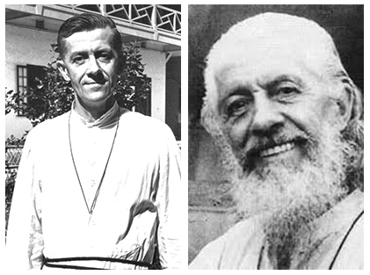

Bishop Vincent McCauley
Born in Iowa in the United States, Bishop McCauley from his childhood dreamed of being a missionary. After studying in the Congregation’s Foreign Mission Seminary, he was sent to East Bengal where he worked among the Kuki Christians near Agartala. Sickness, however, forced him to return to the United States.
Bishop McCauley persevered in his desire to serve in the missions, and in 1958, he led the Congregation’s new mission to Uganda. In 1961, he was appointed bishop of the newly created Diocese of Fort Portal. In addition to building the diocese from the ground up, he was known for his compassion, guiding the Church in aiding countless refugees, widows, and orphans during
the political turmoil of the1960s and 70s. For him, as the Constitutions state, “The face of every human being who suffers is for us the face of Jesus” (8:114).
He died on November 1, 1982 and was buried in the Holy Cross community cemetery at Notre Dame on November 4. In August 2006, the cause for canonization of Bishop McCauley, C.S.C., was introduced in the Congregation of Saints. As Servant of God, Bishop McCauley’s cause undergoes review by the Diocese of Fort Portal, Uganda, Holy Cross seeks to emulate his faith, talent, energy, and joy – gifts by which he made God known, loved, and served.

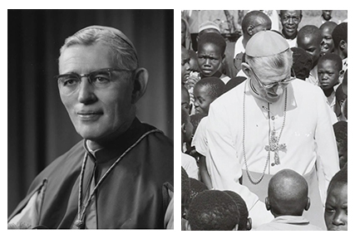

Acknowledgements
All music used with permission. Reprinted under One License, #A-702876 . All rights reserved. Feel free to download in the USA. Excerpts from the English translation from the Liturgy of the Hours © 2010, International Commission on English in Liturgy
Corporation. All rights reserved.

