

YEAR OF MISSION WORSHIP BOOKLET
APRIL 28, 2025—APRIL 28, 2026

TABLE OF CONTENTS
A Few Words About This Worship Booklet | Pg. 3
Morning Prayer on April 28, 2025 | Pg. 4
Eucharistic Celebration on April 28, 2025 | Pg. 12
Evening Prayer on April 28, 2025 | Pg. 19
Morning Prayer on April 28, 2026 | Pg. 28
Eucharistic Celebration on April 28, 2026 | Pg. 36
Evening Prayer on April 28, 2026 | Pg. 43
About Our Patrons: Brother Flavian Laplante and Bishop Vincent McCauley | Pgs. 51—52
Alternative Hymns | Pg. 53
Prayer for the Year of Mission | Pg. 54

A Few Words About this Worship Booklet
In the year 1840, Blessed Basile Moreau, the founder of the Congregation of Holy Cross, sent Brother André Mottais, Brother Alphonsus Rodriguez Tulou, novice Brother Ignace Feron, Father Le Boucher and Father Victor Drouelleto Algiers, the Congregation’s first-ever overseas mission. To mark the 185th Anniversary of their sending, and to celebrate the sending of 8 of our Holy Cross missionaries (4 Brothers and 4 Priests from 7 Jurisdictions and 5 countries) to the Holy Family Mission in the Diocese of Bougainville in Papua New Guinea (PNG), our Superior General, Br. Paul Bednarczyk, C.S.C., announced a Year of Mission with the theme, Hope Beyond Borders, for celebration by the whole family of Holy Cross.
To facilitate this celebration, the General Council created a task force to provide resources for use during this Year of Mission. This booklet is one such resource. It offers Morning Prayer, The Eucharistic Celebration, and Evening Prayer for both the opening (April 28, 2025) and the closing (April 28, 2026) celebrations for the Year of Mission. Please feel free to adapt it to your needs and circumstances.
May the Co-Patrons of this Year of Mission, Servants of God Flavian Laplante and Vincent McCauley, intercede for us all.
Have a fruitful and blessed Year of Mission!
Members of the Task Force
The Year of Mission April 2025
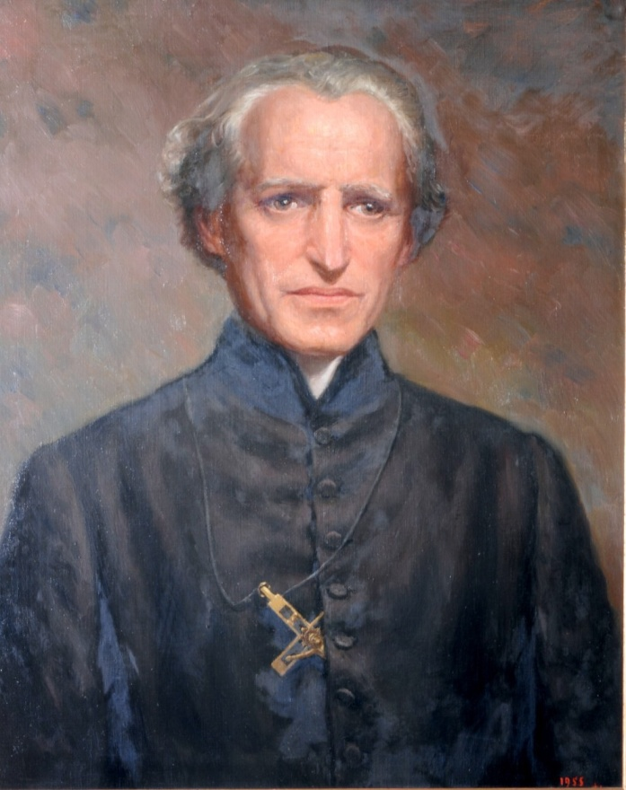

Blessed Basile Anthony Mary Moreau, Founder Congregation of Holy Cross

MORNING PRAYER
April 28, 2025
Verse and Response
God, + come to my assistance.
- Lord, make haste to help me.

Glory to the Father, and to the Son, and to the Holy Spirit:
- as it was in the beginning, is now, and will be forever. Amen. Alleluia.
Hymn | This Day God Gives Me
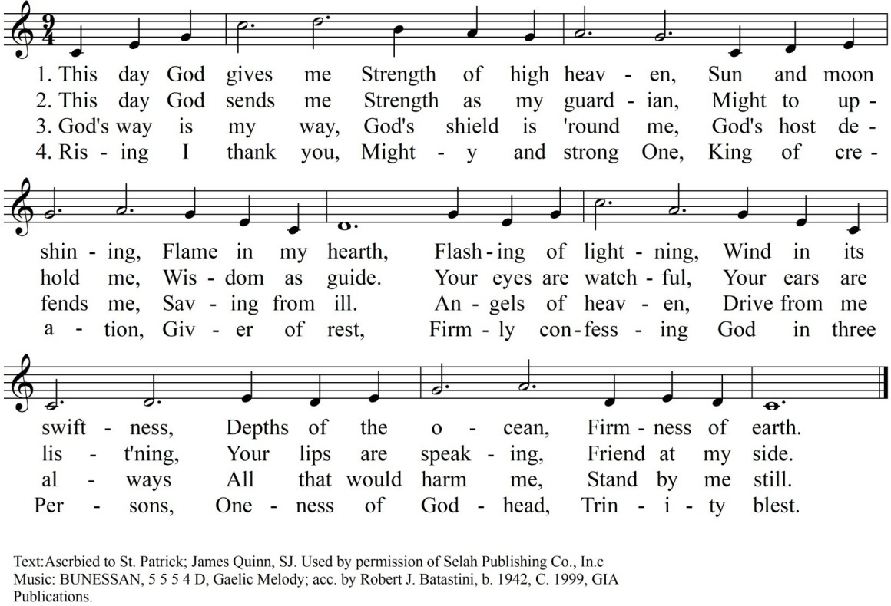

Psalmody
Psalm 42
Leader: As a deer longs for flowing streams, so my soul longs for you, my God, alleluia.
Leader: | All:
Like the deer that yearns for running streams,  so my soul is yearning for you, my God. | My soul is thirsting for God,  the God of my life; when can I enter and see the face of God?
My tears have become my bread, by night, by day,  as I hear it said all the day long:  “Where is your God?” | These things will I remember as I pour out my soul:  how I would lead the rejoicing crowd into the house of God,  amid cries of gladness and thanksgiving,  the throng wild with joy.
Why are you cast down, my soul, why groan within me?  Hope in God; I will praise him still, my Savior and my God. | My soul is cast down within me as I think of you,  from the country of Jordan and Mount Hermon, from the Hill of Mizar.
Deep is calling on deep, in the roar of waters:  your torrents and all your waves swept over me. | By day the Lord will send his loving kindness;  by night I will sing to him, praise the God of my life.
I will say to God, my rock: “Why have you forgotten me?” Why do I go mourning, oppressed by the foe?”
With cries that pierce me to the heart,
my enemies revile me,
saying to me all the day long:
“Where is your God?”
Why are you cast down, my soul, why groan within me?
Hope in God; I will praise him still, my Savior and my God.

All: | Glory to the Father, and to the Son, and to the Holy Spirit:  as it was in the beginning, is now, and will be forever. Amen.  As a deer longs for flowing streams, so my soul longs for you, my God, alleluia.

Canticle—Sirach 36:1-5, 10-13
Leader: Fill Zion with your praises, Lord, and let your wonders be proclaimed, alleluia.
Leader:  Come to our aid, O God of the universe, and put all the nations in dread of you! Raise your hand against the heathen,  that they may realize your power.  Give new signs and work new wonders;  show forth the splendor of your right hand and arm.  Take pity on your holy city,  Jerusalem, your dwelling place. Fill Zion with your majesty,  Your temple with your glory. | All:  As you have used us to show them your holiness, so now use them to show us your glory.  Thus they will know, as we know, that there is no God but you.  Gather all the tribes of Jacob,  that they may inherit the land as of old.  Show mercy to the people called by your name; Israel, whom you named your first-born.

All: | Glory to the Father, and to the Son, and to the Holy Spirit:  as it was in the beginning, is now, and will be forever. Amen.  Fill Zion with your praises, Lord, and let your wonders be proclaimed, alleluia.

Psalm 19A
Leader: The glory of God illumines the city; the Lamb of God is its light, alleluia.
Leader:  The heavens proclaim the glory of God  and the firmament shows forth the work of His hands.  Day unto day takes up the story  and night unto night makes known the message.  There he has placed a tent for the sun;  it comes forth like a bridegroom coming from his tent, rejoices like a champion to run its course. | All:  No speech, no word, no voice is heard  yet their span extends through all the earth,  their words to the utmost bounds of the world.  At the end of the sky is the rising of the sun; to the furthest end of the sky is its course.  There is nothing concealed from its burning heat.

All: | Glory to the Father, and to the Son, and to the Holy Spirit:  as it was in the beginning, is now, and will be forever. Amen.  The glory of God illumines the city; the Lamb of God is its light, alleluia.

Reading | Writings of Father Moreau
If I could have foreseen the development of the Congregation of Holy Cross from the outset, I could then have regulated and coordinated everything in advance. If such were the case, however, the Congregation would have been a merely human combination and not the work of Divine Providence. The fact of the matter is that it began and developed in a manner so mysterious, that I can claim for myself neither credit for its foundation nor merit for its progress. Therein lies the indubitable proof that God alone is the Founder of this Congregation, since, according to St. Augustine, when we cannot find the cause of a good work, we must recognize that the Lord is its beginning and author. (CL 94-1858)
Responsory
The Lord is risen from the tomb, alleluia, alleluia.
—The Lord is risen from the tomb, alleluia, alleluia.
He hung upon the cross for us,
—alleluia, alleluia.
Glory to the Father, and to the Son, and to the Holy Spirit:
—The Lord is risen from the tomb, alleluia, alleluia.
Canticle of Zechariah
Leader: Truly I tell you, unless you are born again you cannot see the kingdom of God, alleluia.
Blessed + be the Lord, the God of Israel;
He has come to his people and set them free.
He has raised up for us a mighty savior, born of the house of his servant David.
Through his holy prophets he promised of old that he would save us from our enemies, from the hands of all who hate us.
He promised to show mercy to our fathers and to remember his holy covenant.
This was the oath he swore to our father Abraham:
to set us free from the hands of our enemies, free to worship him without fear,
holy and righteous in his sight all the days of our life.
You, my child, shall be called the prophet of the Most High; for you will go before the Lord to prepare his way,
to give his people knowledge of salvation by the forgiveness of their sins.
In the tender compassion of our God
the dawn from on high shall break upon us,
to shine on those who dwell in darkness and the shadow of death,
and to guide our feet into the way of peace.
Glory to the Father, and to the Son, and to the Holy Spirit:
as it was in the beginning, is now, and will be forever. Amen.
All: Truly I tell you, unless you are born again you cannot see the kingdom of God, alleluia.

Intercessions
Through the resurrection of your Son, you opened for us the way to eternal life; as we work today, sustain us with the hope of glory.
—Lord, be our light and our hope.
During this Year of Mission, may the Congregation renew its commitment to cross borders of every sort to hasten the coming of the Kingdom.
—Lord, be our light and our hope.
That our Holy Cross missionaries succeed in spreading “Hope Beyond Borders” throughout the world, especially in Papua New Guinea.
—Lord, be our light and our hope.
May the Holy Spirit set the hearts of all those associated with the missionary efforts of the
Congregation of Holy Cross on fire with a burning desire to make the Good News known despite the obstacles that confront them.
—Lord, be our light and our hope.
May our Holy Cross missionaries imitate the heroic work of their predecessors in promoting education, development, and advocacy for human rights throughout the world.
—Lord, be our light and our hope.
As missionaries of hope may we have the competence to see the needs of the people and the courage to address them wherever we serve.
—Lord, be our light and our hope.
Our Father, who art in heaven, hallowed be thy name;
thy kingdom come, thy will be done
on earth as it is in heaven.
Give us this day our daily bread; and forgive us our trespasses
as we forgive those who trespass against us; and lead us not into temptation,
but deliver us from evil.
Almighty and ever-living God,
your Spirit made us your children, confident to call you Father.
Increase your Spirit of love within us
and bring us to our promised inheritance.
Grant this through our Lord Jesus Christ, your Son, who lives and reigns with you and the Holy Spirit, God, forever and ever.
— Amen.

Leader: | Let us pray:
All: | Lord God, source of all goodness, in your divine Providence  You entrusted Blessed Basile Moreau with the task of sending missionaries to spread the light of truth  in response to the needs of your universal Church.  We thank you for those faith-filled religious  who risked going beyond the borders of every sort to proclaim the good news of the kingdom of God.  Enkindle in us all,  members of the Family of Holy Cross, a renewed missionary zeal.  Grant that we may sow the seeds of faith and be heralds of hope to all peoples, especially among the poor,  the oppressed, and the marginalized,  that you may be known, loved, and served.  Through the intercession of  Servants of God Flavian Laplante and Vincent McCauley, give us the grace to respond  generously and wholeheartedly  to the urgent call of evangelization.  We make this prayer in the name of Jesus the Lord. Amen.

Dismissal
Leader: The Lord be with you.
All: And with your spirit.

Leader: May almighty God bless you, the Father, and the Son, and the Holy Spirit.
All: Amen.

Hymn | Let Us Be People of Hope
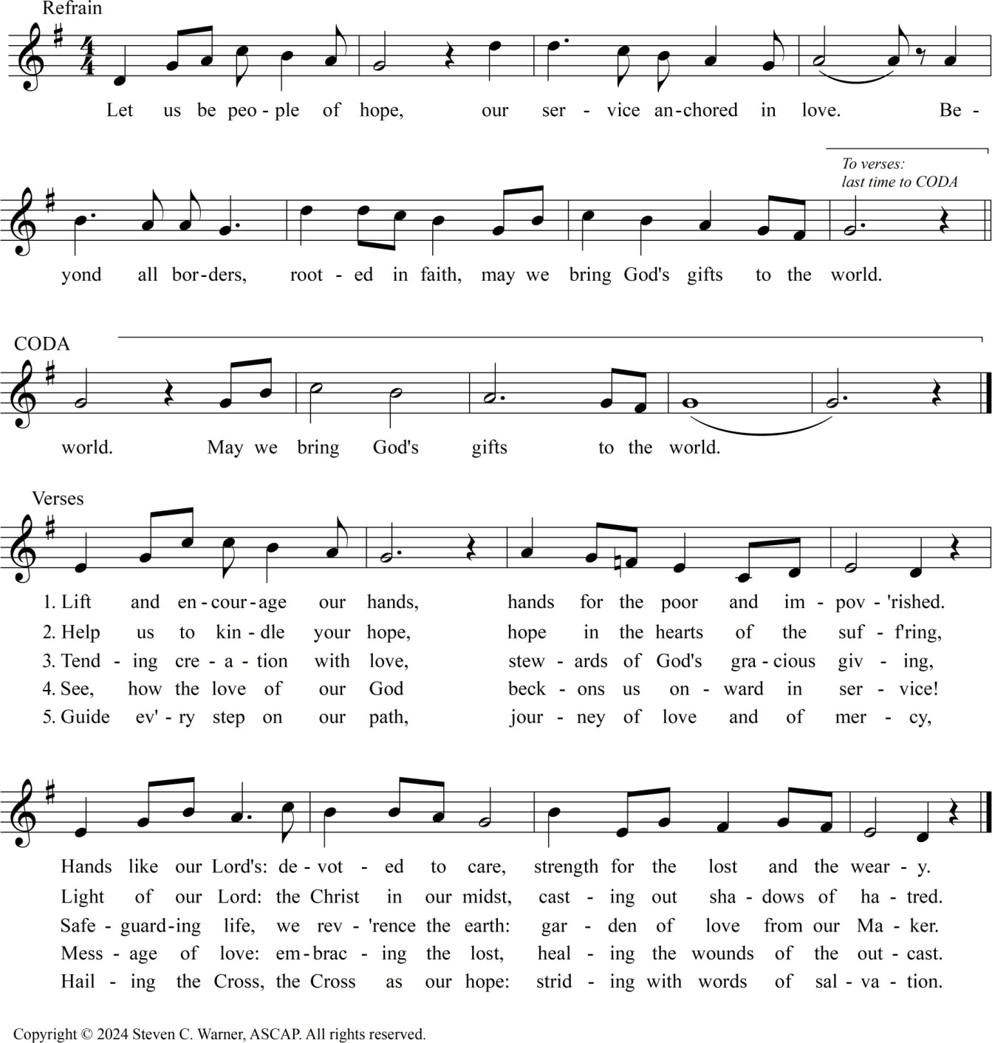

Monday, April 28, 2025
EUCHARISTIC CELEBRATION
THE INTRODUCTORY RITES
Entrance Song | Lord, Whose Love in Humble Service
Greeting
In the name of the Father, and of the Son, and of the Holy Spirit.

OR
The grace of our lord Jesus Christ, and the love of God, and the communion of the holy spirit be with you all.
R. And with your spirit. OR
Grace to you and peace from God our Father and the lord Jesus Christ.
R. And with your spirit.
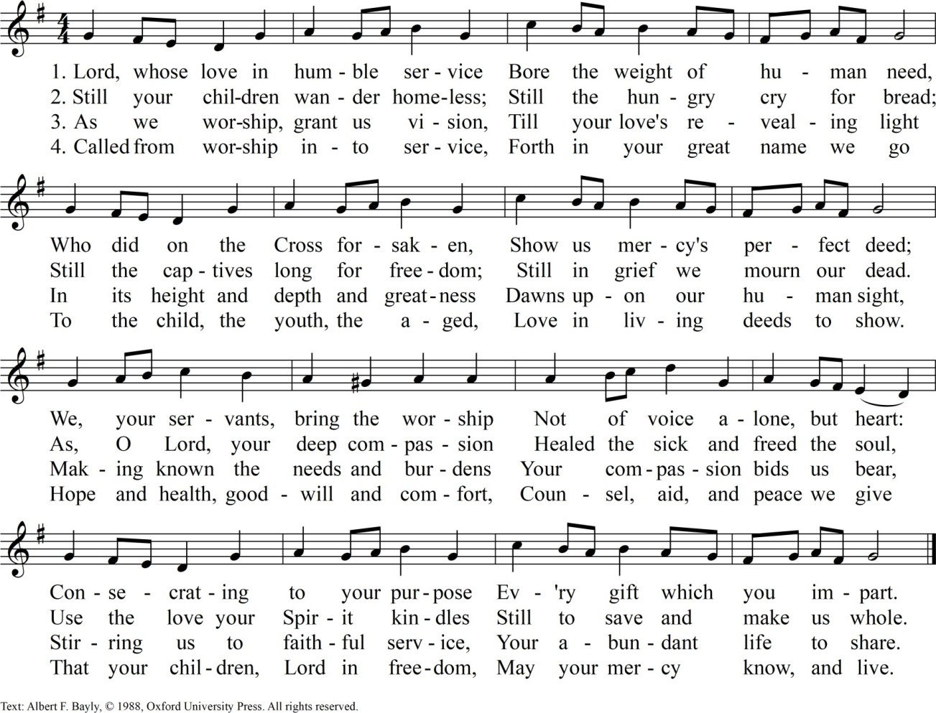

Penitential Act
Brethren (brothers and sisters), let us acknowledge our sins, and so prepare ourselves to celebrate the sacred mysteries.
a brief pause for silence follows. then all recite together the formula of general confession:
I confess to almighty God and to you, my brothers and sisters,
that I have greatly sinned,
in my thoughts and in my words,
in what I have done and in what I have failed to do,
and, striking their breast, they say:
through my fault, through my fault, through my most grievous fault;
then they continue:
therefore I ask Blessed Mary Ever-Virgin, all the Angels and Saints,
and you, my brothers and sisters,
to pray for me to the lord our God.
the absolution by the Priest follows:
may almighty God have mercy on us, forgive us our sins,
and bring us to everlasting life.
R. Amen.

OR
You were sent to heal the contrite of heart: Lord, have mercy.
R. Lord, have mercy.
You came to call sinners: Christ, have mercy.
R. Christ, have mercy.
You are seated at the right hand of the Father to intercede for us: Lord, have mercy.
R. Lord, have mercy.
May almighty God have mercy on us, forgive us our sins,
and bring us to everlasting life.
R. Amen.
Collect
O God,
who in your effable Providence Chose your priest, Blessed Basile
To imitate the virtues of the Holy Family And respond to the needs of the Church, Grant, we beseech you, That supported by his prayers and example, We may have the strength to boldly confess The Cross of Christ as our only hope.
Who lives and reigns with you in the unity Of the Holy Spirit, God, forever and ever.
R. Amen

THE LITURGY OF THEWORD
First Reading | Ephesians 41-7,11-13  Alternative reading: Zechariah 8:20-23
Responsorial Psalm | Psalm 16:1-2a, 5, 7-8, 11
Alleluia
Gospel | Matthew16:24-27  Alternative reading: Mark16:15-20
Homily
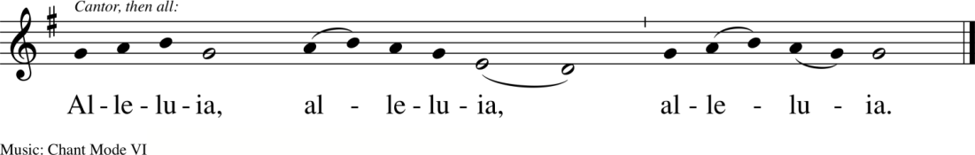

Universal Prayer
Celebrant: The love of Christ gathers us together in communion on this opening day of the Year of Mission, that we might be renewed in our commitment to bring the Gospel to the ends of the earth. Let us raise our hearts to our loving Father for our needs as we undertake this challenge:
We pray for Pope Francis, the bishops, and all the priests and religious brothers and sisters, that they may proclaim the Gospel of Jesus Christ with zeal and compassion and without fear. Lord, hear us:
—Lord, graciously hear us.
We pray for civic leaders, that they be inspired to work to build a world where everyone can live in peace, and that they may care for God’s creation by providing clean water, air, and a healthy environment for all. Lord, hear us:
—Lord, graciously hear us.
We pray for the Congregation of Holy Cross, that in this Year of Mission, all may experience a burning desire to be sent in service beyond their borders to the Church and the world, especially to those living on the margins of society. Lord, hear us:
—Lord, graciously hear us.
We pray for all collaborators with the mission of Holy Cross, that they find nourishment for their souls as they share in the proclamation of His Word. Lord, hear us:
—Lord, graciously hear us.
We pray for the youth of the world, that they may listen carefully to God’s invitations, discover the deepest longing of their hearts, and courageously respond with trusting faith and generous love. Lord, hear us:
—Lord, graciously hear us.
We pray for all the deceased members of Holy Cross and this community, that the Light of God’s love may lead them into the joy of God’s presence forever. Lord, hear us:
—Lord, graciously hear us.
Prayer after the Intercessions
Celebrant: God of love and compassion, you sent your Son among us on a mission to reveal your love for us. Hear our prayers, and grant that we may walk in His way of love, truth, mercy, and compassion. We make this prayer through Christ our Lord.
—Amen.

THE LITURGY OF THE EUCHARIST
Preparation of the Gifts
Prayer Over the Offerings
Eucharistic Acclamations | The Roman Missal
Sanctus
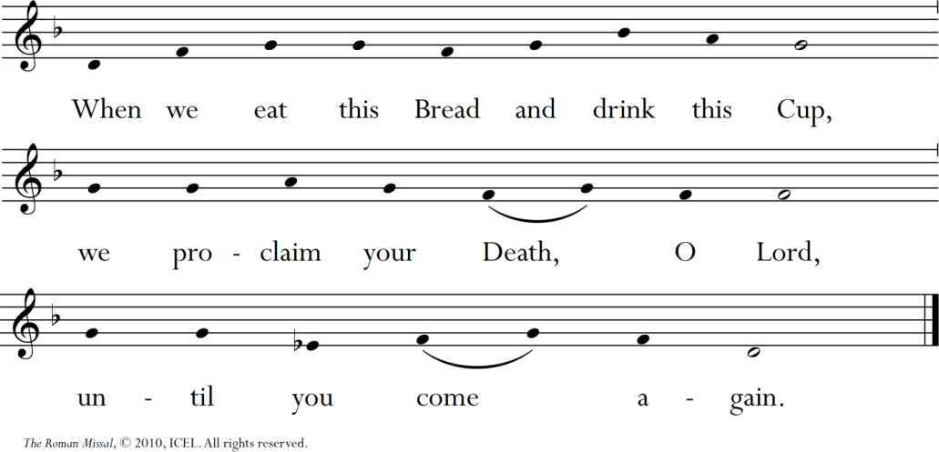
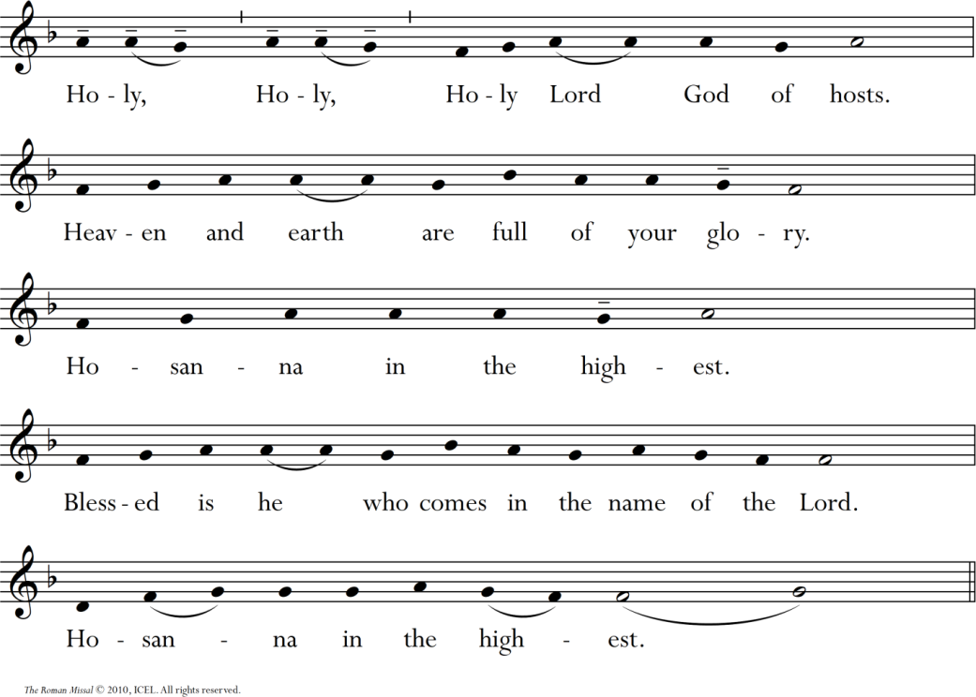

Mystery of Faith
Amen

The Communion Rite
Lord’s Prayer
Sign of Peace
Fraction of the Bread
Communion
Song | Eat This Bread
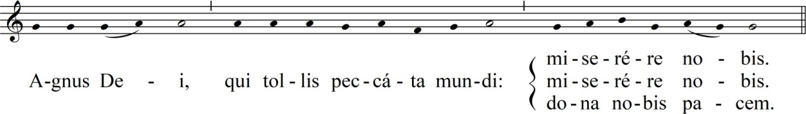
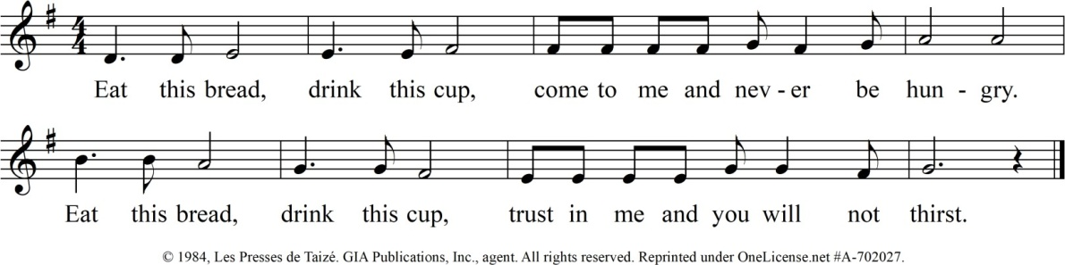

Prayer after Communion
Look with kindness upon your people, O Lord, and grant, we pray,
that those you were pleased to renew by eternal mysteries may attain in their flesh
the incorruptible glory of the resurrection. Through Christ our Lord.
R. Amen.

THE CONCLUDING RITES
The Lord be with you.
R. And with your Spirit.
Blessing May almighty God bless you,
the Father, and the Son, and the Holy Spirit.
R. Amen.
Dismissal
Go forth, the Mass is ended.
OR
Go and announce the Gospel of the Lord. OR
Go in peace, glorifying the Lord by your life. OR
Go in peace.
R. Thanks be to God.
Recessional Hymn | The Spirit Sends Us Forth to Serve
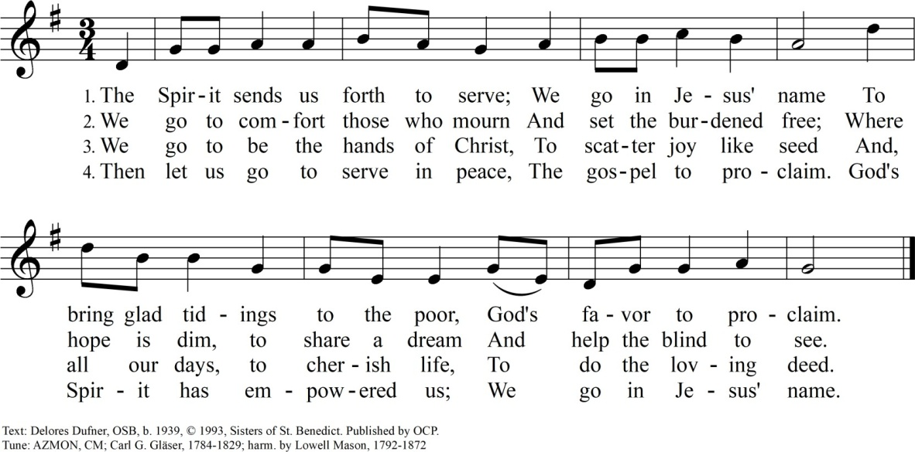

EVENING PRAYER
April 28, 2025
Verse and Response
God, + come to my assistance.
- Lord, make haste to help me.

Glory to the Father, and to the Son, and to the Holy Spirit:
- as it was in the beginning, is now, and will be forever. Amen. Alleluia.
Hymn | O Radiant Light
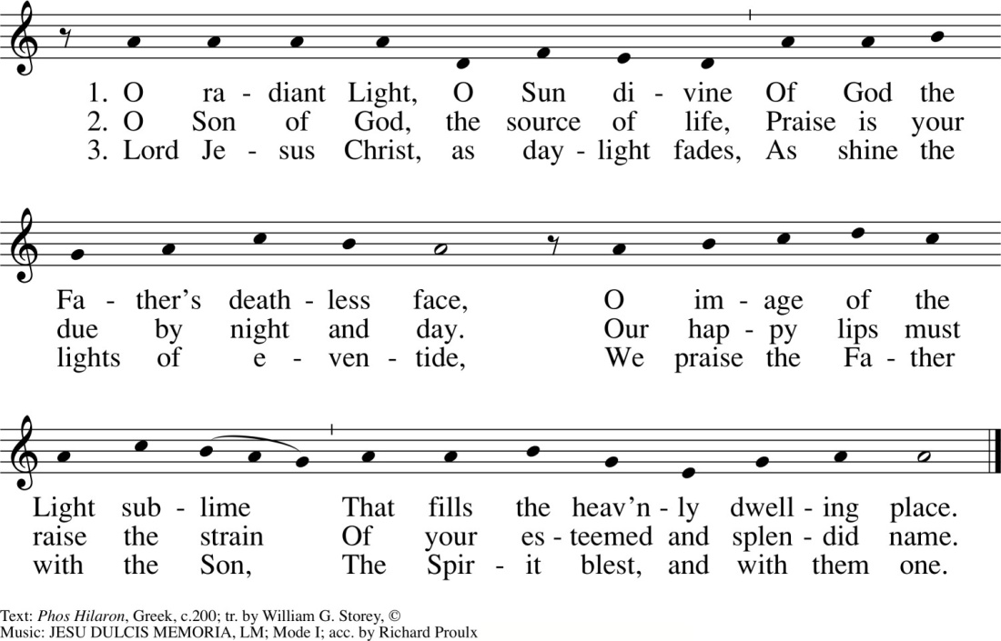

Psalmody
Psalm 45 I
Leader: Blessed is he who comes in the name of the Lord, alleluia.
Leader:  My heart overflows with noble words.  To the king I must speak the song I have made; my tongue as nimble as the pen of a scribe.  O mighty one, gird your sword upon your thigh; in splendor and state, ride on in triumph  for the cause of truth and goodness and right. | All:  You are the fairest of the children of men and graciousness is poured upon your lips: because God has blessed you for evermore.  Take aim with your bow in your dread right hand. Your arrows are sharp: peoples fall beneath you. The foes of the king fall down and lose heart.
Your throne, O God, shall endure forever.
A scepter of justice is the scepter of your kingdom.
Your love is for justice; your hatred for evil.
 | Therefore God, your God, has anointed you with the oil of gladness above other kings: your robes are fragrant with aloes and myrrh.
From the ivory palace you are greeted with music. The daughters of kings are among your loved ones.
On your right stands the queen in gold of Ophir.

All: | Glory to the Father, and to the Son,  and to the Holy Spirit:  as it was in the beginning, is now, and will be forever. Amen.  Blessed is he who comes in the name of the Lord, alleluia.

Psalmody
Psalm 45 II
Leader: Blessed are those who are called to the wedding feast of the Lamb, alleluia.
Leader:  Listen, O daughter, give ear to my words:  forget your own people and your father’s house. So will the king desire your beauty:  he is your lord, pay homage to him. | All:  And the people of Tyre shall come with gifts,  the richest of the people shall seek your favor.  The daughter of the king is clothed with splendor, her robes embroidered with pearls set in gold.
She is led to the king with her maiden companions. They are escorted amid gladness and joy;
they pass within the palace of the king.
Sons shall be yours in place of your fathers: you will make them princes over all the earth.
May this song make your name for ever remembered.
May the peoples praise you from age to age.

All: | Glory to the Father, and to the Son, and to the Holy Spirit:  as it was in the beginning, is now, and will be forever. Amen.  Blessed are those who are called to the wedding feast of the Lamb, alleluia.

Canticle—Ephesians 1:3-10
Leader: From his fullness we have all received, grace upon grace, alleluia.
Leader:  Praised be the God and Father of our Lord Jesus Christ,  who has bestowed on us in Christ  every spiritual blessing in the heavens.  He predestined us  to be his adopted sons through Jesus Christ, such was his will and pleasure,  that all might praise the glorious favor he has bestowed on us in his beloved.  God has given us the wisdom  to understand fully the mystery, the plan he was pleased  to decree in Christ. | All:  God chose us in him before the world began to be holy  and blameless in his sight.  In him and through his blood, we have been redeemed, and our sins forgiven,  so immeasurably generous  is God’s favor to us.  A plan to be carried out  in Christ, in the fullness of time,  to bring all things into one in him, in the heavens and on earth.

All: | Glory to the Father, and to the Son,  and to the Holy Spirit:  as it was in the beginning, is now, and will be forever. Amen.  From his fullness we have all received, grace upon grace, alleluia.

Reading | Writings of Father Moreau
Holy Cross is not a human work, but God’s very own. Woe to whoever would wish to change it by leading it into paths different from those followed by Divine Providence in its foundation. If each member continues to carry out his own particular obedience in a spirit of loyalty and simplicity, and with the spirit of union which is now inspiring all the members of the Association, God will bless our whole Congregation. (CL40 -1850)
Responsory
The disciples rejoiced, alleluia, alleluia.
—The disciples rejoiced, alleluia, alleluia.
When they saw the risen Lord,
—alleluia, alleluia.
Glory to the Father, and to the Son, and to the Holy Spirit:
—The disciples rejoiced, alleluia, alleluia.
Canticle of Mary
Leader: What is born of the flesh is flesh, and what is born of the spirit is spirit, alleluia.
My + soul proclaims the greatness of the Lord,
my spirit rejoices in God my Savior
for he has looked with favor on his lowly servant.
From this day all generations will call me blessed: the Almighty has done great things for me,
and holy is his Name.

He has mercy on those who fear him in every generation.
He has shown the strength of His arm,
He has scattered the proud in their conceit.
He has cast down the mighty from their thrones, and has lifted up the lowly.

He has filled the hungry with good things, and the rich he has sent away empty.

He has come to the help of his servant Israel for he has remembered his promise of mercy, the promise he made to our fathers,
to Abraham and his children for ever.
Glory to the Father, and to the Son, and to the Holy Spirit:
as it was in the beginning, is now, and will be forever. Amen.
All: What is born of the flesh is flesh, and what is born of the spirit is spirit, alleluia.

Intercessions
Lord Jesus Christ, you walked with your disciples on the way; be with your Church on its pilgrimage through life.
—Christ, our hope, hear our prayer.
In this Year of Mission, may we comfort the poor and strengthen the oppressed wherever we may encounter them.
—Christ, our hope, hear our prayer.
That we may be on fire for the Kingdom of God, with unwavering trust in Divine Providence and zeal for the missions, through the Cross, our only Hope
—Christ, our hope, hear our prayer.
That we may be missionaries of compassion to the poor and afflicted as we speak of hope and assist them to find relief.
—Christ, our hope, hear our prayer.
Through all our many ministries, may we continue to educate in the faith by developing minds, cultivating hearts, and encouraging hope in the Cross.
—Christ, our hope, hear our prayer.
Jesus, the new Adam and life-giving spirit, transform the Holy Cross men and women who have gone before us into your own likeness, that the fullness of your joy may be theirs.
—Christ, our hope, hear our prayer.
Our Father, who art in heaven, hallowed be thy name;
thy kingdom come, thy will be done
on earth as it is in heaven.
Give us this day our daily bread; and forgive us our trespasses
as we forgive those who trespass against us;
and lead us not into temptation,
but deliver us from evil.
Almighty and ever-living God,
your Spirit made us your children, confident to call you Father.
Increase your Spirit of love within us
and bring us to our promised inheritance.
Grant this through our Lord Jesus Christ, your Son, who lives and reigns with you and the Holy Spirit, God, forever and ever.
— Amen.

Leader: | Let us pray:
All: | Lord God, source of all goodness, in your divine Providence  You entrusted Blessed Basile Moreau with the task of sending missionaries to spread the light of truth  in response to the needs of your universal Church.  We thank you for those faith-filled religious  who risked going beyond the borders of every sort to proclaim the good news of the kingdom of God.  Enkindle in us all,  members of the Family of Holy Cross,  a renewed missionary zeal.  Grant that we may sow the seeds of faith and be heralds of hope to all peoples, especially among the poor,  the oppressed, and the marginalized,  that you may be known, loved, and served.  Through the intercession of  Servants of God Flavian Laplante and Vincent McCauley, give us the grace to respond  generously and wholeheartedly  to the urgent call of evangelization.  We make this prayer in the name of Jesus the Lord. Amen.

Dismissal
Leader: The Lord be with you.
All: And with your spirit.

Leader: May almighty God bless you, the Father, and the Son, and the Holy Spirit.
All: Amen.

Hymn | Let Us Be People of Hope

THE CLOSING DAY OF THE YEAR OF MISSION

MORNING PRAYER
April 28, 2026
Verse and Response
God, + come to my assistance.
- Lord, make haste to help me.

Glory to the Father, and to the Son, and to the Holy Spirit:
- as it was in the beginning, is now, and will be forever. Amen. Alleluia.
Hymn | This Day God Gives Me

Psalmody
Psalm 101
Leader: Whoever does the will of my Father will enter the kingdom of heaven, alleluia.
Leader:  My song is of mercy and justice; I sing to you, O Lord.  I will walk in the way of perfection. O when, Lord, will you come?  I will hate the ways of the crooked; They shall not be my friends.  The false-hearted must keep far away; The wicked I disown.  I look to the faithful in the land That they may dwell with me.  He who walks in the way of perfection Shall be my friend.  Morning by morning I will silence All the wicked in the land, Uprooting from the city of the Lord  All who do evil. | All:  I will walk with blameless heart  Within my house;  I will not set before my eyes Whatever is base.  The man who slanders his neighbor in secret I will bring to silence.  The man of proud looks and haughty heart I will never endure.  No man who practices deceit Shall live within my house.  No man who utters lies shall stand Before my eyes.

All: | Glory to the Father, and to the Son, and to the Holy Spirit:  as it was in the beginning, is now, and will be forever. Amen.  Whoever does the will of my Father will enter the kingdom of heaven, alleluia.

Canticle—Daniel 3:26, 27, 29, 34-41
Leader: Let all the nations, O Lord, know the depths of your loving mercy for us, alleluia.
Leader:  Blessed are you, and praiseworthy, O Lord, the God of our fathers, and glorious forever is your name.  For we have sinned and transgressed by departing from you,  and we have done every kind of evil.  Do not take away your mercy from us, for the sake of Abraham, your beloved,  Isaac your servant, and Israel your holy one,  For we are reduced, O Lord, beyond any other nation, brought low everywhere in the world this day  because of our sins.  But with contrite heart and humble spirit let us be received;  as though it were holocausts of rams and bullocks, or thousands of fat lambs,  so let our sacrifice be in your presence today  as we follow you unreservedly;  for those who trust in you cannot be put to shame. | All:  For you are just in all you have done;  all your deeds are faultless, all your ways right,  and all your judgments proper.  For your name’s sake, do not deliver us up forever, or make void your covenant.  to whom you promised to multiply their offspring like the stars of heaven,  or the sand on the shore of the sea.  We have in our day no prince, prophet, or leader, no holocaust, sacrifice, oblation, or incense,  no place to offer first fruits, to find favor with you.  And now we follow you with our whole heart, we fear you and we pray to you.

All: | Glory to the Father, and to the Son, and to the Holy Spirit:  as it was in the beginning, is now, and will be forever. Amen.  Let all the nations, O Lord, know the depths of your loving mercy for us, alleluia.

Psalm 144:1-10
Leader: The Lord is my refuge and my savior, alleluia.
Leader:  Blessed be the Lord, my rock, who trains my arms for battle, who prepares my hands for war.  Lord, what is man that you care for him, mortal man, that you keep him in mind; man, who is merely a breath,  whose life fades like a passing shadow?  Reach down from heaven and save me; draw me out from the mighty waters,  from the hands of alien foes whose mouths are filled with lies,  whose hands are raised in perjury. | All:  He is my love, my fortress;  He is my stronghold, my Savior my shield, my place of refuge. He brings peoples under my rule.  Lower your heavens and come down;  touch the mountains; wreathe them in smoke. Flash your lightnings; rout the foe,  shoot your arrows and put them to flight.  To you, O God, will I sing a new song;  I will play on the ten-stringed harp to you who give kings their victory,  who set David your servant free.

All: | Glory to the Father, and to the Son,  and to the Holy Spirit:  as it was in the beginning, is now, and will be forever. Amen.  The Lord is my refuge and my Savior, alleluia.

Reading | Writings of Father Moreau
What is true of a palace whose foundations have been laid, and which is rising gradually until completion is verified, likewise, in a great work of charity. It is not one alone who builds; nor is it one stone, or one single beam of wood that forms it. Each worker contributes something from his own trade; each stone is cut to fit into its one appointed place; and each piece of wood is arranged and placed so as to enhance the general effect of the entire building. Union, then, is a powerful lever with which we could move, direct, and sanctify the whole world, if the spirit of evil, who has been allowed to exercise his power over this earth does not set himself up against the wondrous effects of this moral force. (CL 5 – 1841)
Responsory
The Lord is risen from the tomb, alleluia, alleluia.
—The Lord is risen from the tomb, alleluia, alleluia.
He hung upon the cross for us,
—alleluia, alleluia.
Glory to the Father, and to the Son, and to the Holy Spirit:
—The Lord is risen from the tomb, alleluia, alleluia.
Canticle of Zechariah
Leader: The works that I do in the name of my Father speak on my behalf, alleluia.
Blessed + be the Lord, the God of Israel;
He has come to his people and set them free.
He has raised up for us a mighty savior, born of the house of his servant David.
Through his holy prophets he promised of old that he would save us from our enemies, from the hands of all who hate us.
He promised to show mercy to our fathers and to remember his holy covenant.
This was the oath he swore to our father Abraham:
to set us free from the hands of our enemies, free to worship him without fear,
holy and righteous in his sight all the days of our life.
You, my child, shall be called the prophet of the Most High; for you will go before the Lord to prepare his way,
to give his people knowledge of salvation by the forgiveness of their sins.
In the tender compassion of our God
the dawn from on high shall break upon us,
to shine on those who dwell in darkness and the shadow of death,
and to guide our feet into the way of peace.
Glory to the Father, and to the Son, and to the Holy Spirit:
as it was in the beginning, is now, and will be forever. Amen.
All: The works that I do in the name of my Father speak on my behalf, alleluia.

Intercessions
Source of all life, as we arrive on the last of the Year of Mission, bless all those who have helped us to see your providential hand at work at every moment of our life in Holy Cross. Send into our hearts the spirit of our founder Blessed Basil Moreau, that we may resolutely place our trust in you alone.
—Source of all life, raise us to new life.
Now that the old leaven of wickedness and evil is destroyed, may we always feed on the unleavened bread of sincerity and truth.
—Source of all life, raise us to new life.
May the Spirit continue to grant all those who partner with the missionary efforts of the Congregation of Holy Cross a passionate desire to share the Good News with those hungry for God.
—Source of all life, raise us to new life.
Through our missionary work, may we continue to help relieve the loneliness, poverty, and suffering of victims of injustice
—Source of all life, raise us to new life.
May we faithfully support our missionaries who labor in places plagued by violence and terror with fervent prayers for their safety and their ministry,
—Source of all life, raise us to new life.
Our Father, who art in heaven, hallowed be thy name;
thy kingdom come, thy will be done
on earth as it is in heaven.
Give us this day our daily bread; and forgive us our trespasses
as we forgive those who trespass against us; and lead us not into temptation,
but deliver us from evil.
Almighty God,
as we celebrate the resurrection, may we share with each other
the joy the risen Christ has won for us.
We ask this through our Lord Jesus Christ, your Son, who lives and reigns with you and the Holy Spirit, God, forever and ever.
— Amen.

Leader: | Let us pray:
All: | Lord God, source of all goodness, in your divine Providence  You entrusted Blessed Basile Moreau with the task of sending missionaries to spread the light of truth  in response to the needs of your universal Church.  We thank you for those faith-filled religious  who risked going beyond the borders of every sort to proclaim the good news of the kingdom of God.  Enkindle in us all,  members of the Family of Holy Cross, a renewed missionary zeal.  Grant that we may sow the seeds of faith and be heralds of hope to all peoples, especially among the poor,  the oppressed, and the marginalized,  that you may be known, loved, and served.  Through the intercession of  Servants of God Flavian Laplante and Vincent McCauley, give us the grace to respond  generously and wholeheartedly  to the urgent call of evangelization.  We make this prayer in the name of Jesus the Lord. Amen.

Dismissal
Leader: The Lord be with you.
All: And with your spirit.

Leader: May almighty God bless you, the Father, and the Son, and the Holy Spirit.
All: Amen.

Hymn | Let Us Be People of Hope

Tuesday, April 28, 2026
EUCHARISTIC CELEBRATION
THE INTRODUCTORY RITES
Entrance Song | The Joy of the Gospel
Greeting
In the name of the Father, and of the Son, and of the Holy Spirit.

OR
The grace of our lord Jesus Christ, and the love of God, œ œ and the communion of the holy spirit be with you all.
R. And with your spirit. OR
Grace to you and peace from God our Father and the lord Jesus Christ.
R. And with your spirit.
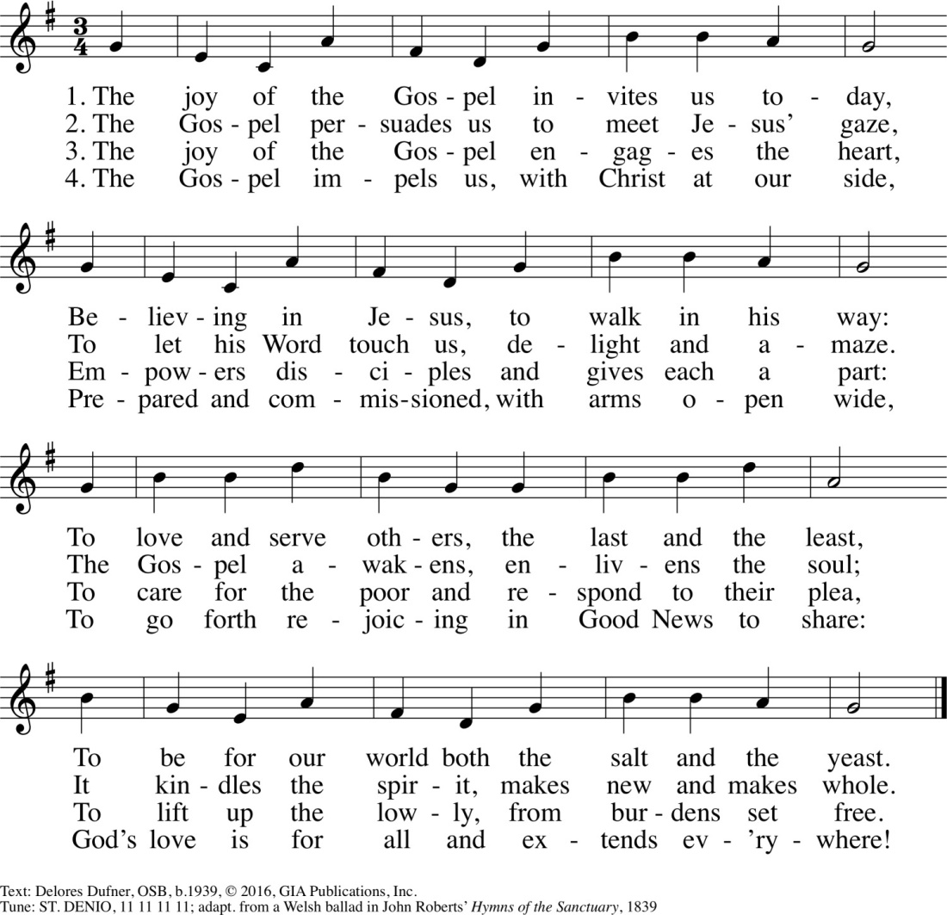

Penitential Act
Brethren (brothers and sisters), let us acknowledge our sins, and so prepare ourselves to celebrate the sacred mysteries.
a brief pause for silence follows. then all recite together the formula of general confession:
I confess to almighty God and to you, my brothers and sisters,
that I have greatly sinned,
in my thoughts and in my words,
in what I have done and in what I have failed to do,
and, striking their breast, they say:
through my fault, through my fault, through my most grievous fault;
then they continue:
therefore I ask Blessed Mary Ever-Virgin, all the Angels and Saints,
and you, my brothers and sisters,
to pray for me to the lord our God.
the absolution by the Priest follows:
may almighty God have mercy on us,
forgive us our sins,
and bring us to everlasting life.
R. Amen.

OR
You were sent to heal the contrite of heart: Lord, have mercy.
R. Lord, have mercy.
You came to call sinners: Christ, have mercy.
R. Christ, have mercy.
You are seated at the right hand of the Father to intercede for us: Lord, have mercy.
R. Lord, have mercy.
May almighty God have mercy on us, forgive us our sins,
and bring us to everlasting life.
R. Amen.
Collect
Grant, we pray, almighty God,
that, celebrating the mysteries of the Lord’s Resurrection, we may merit to receive the joy of our redemption.
Through our lord Jesus Christ, your son,
who lives and reigns with you in the unity of the holy spirit, God, forever and ever.
R. Amen

THE LITURGY OF THE WORD
First Reading | 1 Peter 4:7b-11  Alternative reading: Timothy 2:1-8
Responsorial Psalm | Psalm 112:1-9
Alleluia
Gospel | Matthew 11:25-30  Alternative reading: Mark 16:15-20
Homily

Universal Prayer
Celebrant: At the end of our journey through the Year of Mission, may we unite with the whole community of the faithful in prayer as we lift our hearts to God, our loving Father:

For our Pope, our Bishop…. and all Church leaders: may they be given the strength to follow the example of Christ who came not to be served, but to serve. Let us pray to the Lord:
—Lord, here our pray.
For all Holy Cross missionaries, especially those working in places of danger and persecution: may they find the courage and wisdom to be powerful Gospel leaven in the world. Let us pray to the Lord:
—Lord, here our pray.
For those who suffer through poverty, violence, racial and ethnic bias, and oppression: may the power of the Gospel heal division, dispel the darkness of ignorance, and bring hope to those who despair. Let us pray to the Lord:
—Lord, here our pray.
For all who are making vocational choices: that the Holy Spirit will inspire them to share their love and gifts fully through the consecrated life in the Congregation of Holy Cross. Let us pray to the Lord:
—Lord, here our pray.
We pray for those who are suffering today: Lord Jesus, you know our weaknesses and our temptations and you were no stranger to suffering. Strengthen all those who are struggling under heavy burdens. Let us pray to the Lord:
—Lord, here our pray.
For all the faithful departed in places served by the Congregation of Holy Cross, that the Lord may welcome them into his everlasting glory. Let us pray to the Lord:
—Lord, here our pray.
Prayer after the Intercessions
Celebrant: Loving Father, we thank You for the gift of Your Son and the call to share His love with the world through the charism of our founder Blessed Basile Moreau. Hear our prayers, and help us to continue with zeal the mission of the Congregation of Holy Cross to be faithful witnesses of Your mercy and grace. We ask this through Christ our Lord.
—Amen.

THE LITURGY OF THEEUCHARIST
Preparation of the Gifts
Prayer Over the Offerings
Eucharistic Acclamations | The Roman Missal
Sanctus
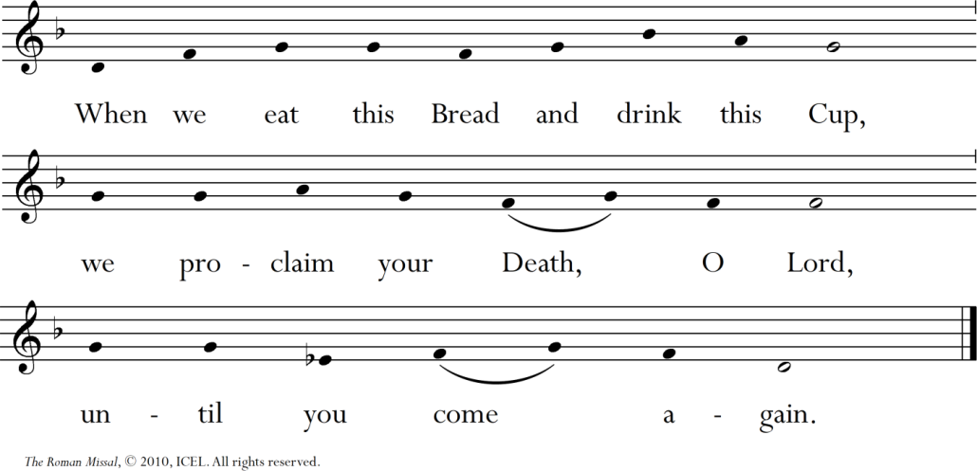

Mystery of Faith
Amen

The Communion Rite
Lord’s Prayer
Sign of Peace
Fraction of the Bread
Communion
Song | Eat This Bread

Prayer after Communion
Hear, O Lord, our prayers,
that this most holy exchange,
by which you have redeemed us,
may bring your help in this present life and ensure for us eternal gladness Through Christ our Lord.
R. Amen.

THE CONCLUDING RITES
The Lord be with you.
R. And with your Spirit.
Blessing May almighty God bless you,
the Father, and the Son, and the Holy Spirit.
R. Amen.
Dismissal
Go forth, the Mass is ended.
OR
Go and announce the Gospel of the Lord. OR
Go in peace, glorifying the Lord by your life. OR
Go in peace.
R. Thanks be to God.
Recessional Hymn | The Spirit Sends Us Forth to Serve

EVENING PRAYER
April 28, 2026
Verse and Response
God, + come to my assistance.
- Lord, make haste to help me.

Glory to the Father, and to the Son, and to the Holy Spirit:
- as it was in the beginning, is now, and will be forever. Amen. Alleluia.
Hymn | God of Day and God of Darkness
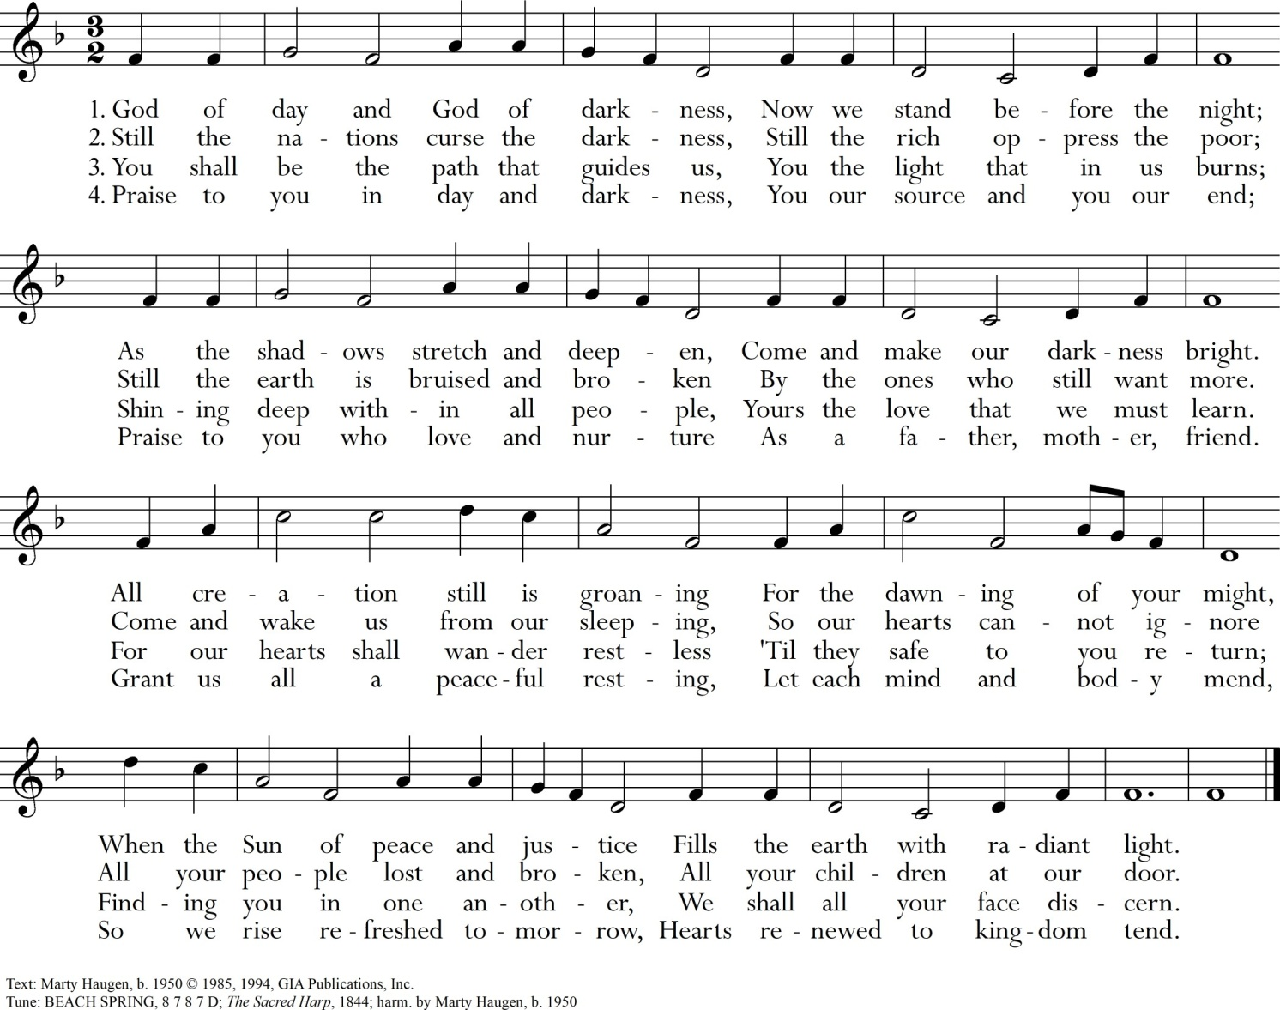

Psalmody
Psalm 137:1-6
Leader: Sing for us one of Zion’s songs, alleluia.
Leader:  By the rivers of Babylon there we sat and wept, remembering Zion;  on the poplars that grew there we hung up our harps.  O how could we sing the song of the Lord on alien soil?  If I forget you, Jerusalem, let my right hand wither! | All:  For it was there that they asked us, our captors, for songs,  our oppressors, for joy. “Sing to us,” they said, “one of Zion’s songs.”  O let my tongue  cleave to my mouth  if I remember you not, if I prize not Jerusalem  above all my joys!

All: | Glory to the Father, and to the Son, and to the Holy Spirit:  as it was in the beginning, is now, and will be forever. Amen.  Sing for us one of Zion’s songs, alleluia.

Psalm 138
Leader: Though I am surrounded by affliction, you preserve my life, alleluia.
Leader:  I thank you, Lord, with all my heart,  You have heard the words of my mouth.  In the presence of the angels I will bless you. I will adore before Your holy temple.  All earth’s kings shall thank you  when they hear the words of your mouth. They shall sing of the Lord’s ways: “How great is the glory of the Lord!”  You stretch out your hand and save me, Your hand will do all things for me.  Your love, O Lord, is eternal,  discard not the work of Your hands. | All:  I thank you for your faithfulness and love which excel all we ever knew of you.  On the day I called, you answered; you increased the strength of my soul.  The Lord is high yet he looks on the lowly and the haughty he knows from afar.  Though I walk in the midst of affliction  you give me life and frustrate my foes.

All: | Glory to the Father, and to the Son, and to the Holy Spirit:  as it was in the beginning, is now, and will be forever. Amen.  Though I am surrounded by affliction, you preserve my life, alleluia.

Canticle—Revelation 4:11, 5:9, 10, 12
Leader: Yours, O Lord, is majesty and power, glory and triumph, alleluia.
Leader:  O Lord our God, you are worthy  to receive glory and honor and power.  Worthy are you, O Lord,  to receive the scroll and break open its seals.  You made of them a kingdom, and priests to serve our God, and they shall reign on theearth. | All:  For you have created all things;  by your will they came to be and were made.  For you were slain;  with your blood you purchased for God men of every race and tongue,  of every people and nation.  Worthy is the Lamb that was slain to receive power and riches, wisdom and strength,  honor and glory and praise.

All: | Glory to the Father, and to the Son, and to the Holy Spirit:  as it was in the beginning, is now, and will be forever. Amen.  Yours, O Lord, is majesty and power, glory and triumph, alleluia.

Reading | Writings of Father Moreau
By zeal is understood that flame of burning desire which one feels to make God known,, loved and served and thus save souls. Apostolic activity is therefore the essential character of this virtue; and every [one] who is animated by this virtue will fulfill the duties of his state with eagerness, affection, courage and perseverance…He will feel that which St. Paul felt for the Galatians whom he had evangelized: “My little children for whom I am in labor until Christ Jesus be formed within you.”…Our zeal is always guided by charity, everything is done with strength and gentleness: strength because we are courageous and unshakable in the midst of
pain, difficulty and trials…and gentleness because we have the tenderness of our Divine Model.
(Christian Pedagogy, I:1, art.4-1856)
Responsory
The disciples rejoiced, alleluia, alleluia.
—The disciples rejoiced, alleluia, alleluia.
When they saw the risen Lord,
—alleluia, alleluia.
Glory to the Father, and to the Son, and to the Holy Spirit:
—The disciples rejoiced, alleluia, alleluia.
Canticle of Mary
Leader: I know my sheep and they follow me; I give them eternal life, alleluia.
My + soul proclaims the greatness of the Lord, my spirit rejoices in God my Savior
for He has looked with favor on His lowly servant.

From this day all generations will call me blessed: the Almighty has done great things for me,
and holy is His name.

He has mercy on those who fear Him in every generation.
He has shown the strength of His arm,
He has scattered the proud in their conceit.
He has cast down the mighty from their thrones, and has lifted up the lowly.

He has filled the hungry with good things, and the rich He has sent away empty.

He has come to the help of His servant Israel for He has remembered His promise of mercy, the promise he made to our fathers,
to Abraham and his children forever.
Glory to the Father, and to the Son, and to the Holy Spirit:
as it was in the beginning, is now, and will be forever. Amen.
All: I know my sheep and they follow me; I give them eternal life, alleluia.

Intercessions
Chief shepherd, after your resurrection you made Peter shepherd of your flock when he professed his love for you. Increase from day to day the love and devotion of Francis, our Pope.
—Lord Jesus, you live forever; hear our prayer.
May you guide the hands and hearts of those who lead us in the Congregation of Holy Cross,
especially our Superior General and his Councilors, Provincials and their Councilors, and all those hold positions of leadership, that they may faithfully preserve the charism of our founder Blessed Basile Moreau.
—Lord Jesus, you live forever; hear our prayer.
At the lakeside you prepared bread and fish for your disciples, open our eyes to see the needs of others and help us to sow seeds of hope in your eternal love and care for us.
—Lord Jesus, you live forever; hear our prayer.
May we continue to participate in God's mission as educators in the faith, reaching out to the afflicted, the poor, and the oppressed.
—Lord Jesus, you live forever; hear our prayer.
As we move forward, may we seek with renewed resilience, boldness, and zeal to serve the needs of the church and the world by going beyond borders of every sort.
—Lord Jesus, you live forever; hear our prayer.
Judge of the living and the dead, forgive the sins of the faithful departed including all those Holy Cross
men and women who gone before us.
—Lord Jesus, you live forever; hear our prayer.
Our Father, who art in heaven, hallowed be thy name;
thy kingdom come, thy will be done
on earth as it is in heaven.
Give us this day our daily bread; and forgive us our trespasses
as we forgive those who trespass against us; and lead us not into temptation,
but deliver us from evil.
Almighty God,
as we celebrate the resurrection, may we share with each other
the joy the risen Christ has won for us.
We ask this through our Lord Jesus Christ, your Son, who lives and reigns with you and the Holy Spirit, God, forever and ever.
— Amen.

Leader: | Let us pray:
All: | Lord God, source of all goodness, in your divine Providence  You entrusted Blessed Basile Moreau with the task of sending missionaries to spread the light of truth  in response to the needs of your universal Church.  We thank you for those faith-filled religious  who risked going beyond the borders of every sort to proclaim the good news of the kingdom of God.  Enkindle in us all,  members of the Family of Holy Cross, a renewed missionary zeal.  Grant that we may sow the seeds of faith and be heralds of hope to all peoples, especially among the poor,  the oppressed, and the marginalized,  that you may be known, loved, and served.  Through the intercession of  Servants of God Flavian Laplante and Vincent McCauley, give us the grace to respond  generously and wholeheartedly  to the urgent call of evangelization.  We make this prayer in the name of Jesus the Lord. Amen.

Dismissal
Leader: The Lord be with you.
All: And with your spirit.

Leader: May almighty God bless you, the Father, and the Son, and the Holy Spirit.
All: Amen.

Hymn | Let Us Be People of Hope

Brother Flavian Laplante, C.S.C.
Born in Québec, Canada, Br. Flavian entered Holy Cross at the age of 16. Upon Final Profession in 1928, he worked at Collège Notre-Dame before heading to the Congregation’s mission in East Bengal (present-day Bangladesh and India) in 1932. He was a builder of schools and orphanages, a teacher, an administrator, a principal of schools and a hermit.
In May 1942, when the Japanese Army started air raids on Chittagong, Br. Flavian went to assist. There he met the fishermen to whom he devoted most of the rest of his life. After completing 49 years of service to the poor in Bangladesh, he died there on June 19, 1981. In the words of the Congregation’s Constitutions, Br. Flavian “[came] not just as servants but as their neighbors, to be with them and of them” (2:13).
Flavian was declared a Servant of God on February 13, 2009 – the Feast of Our Lady of Lourdes – by Most Rev. Patrick D’Rozario, Bishop of Chittagong Diocese, Bangladesh. His cause is being advanced by coordinated work in Bangladesh and in Canada.

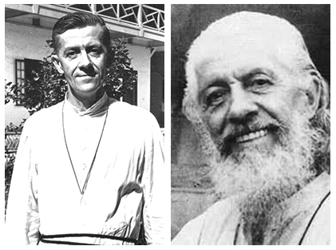

Bishop Vincent McCauley
Born in Iowa in the United States, Bishop McCauley from his childhood dreamed of being a missionary. After studying in the Congregation’s Foreign Mission Seminary, he was sent to East Bengal where he worked among the Kuki Christians near Agartala. Sickness, however, forced him to return to the United States.
Bishop McCauley persevered in his desire to serve in the missions, and in 1958, he led the Congregation’s new mission to Uganda. In 1961, he was appointed bishop of the newly created Diocese of Fort Portal. In addition to building the diocese from the ground up, he was known for his compassion, guiding the Church in aiding countless refugees, widows, and orphans during
the political turmoil of the 1960s and 70s. For him, as the Constitutions state, “The face of every human being who suffers is for us the face of Jesus” (8:114).
He died on November 1, 1982 and was buried in the Holy Cross community cemetery at Notre Dame on November 4. In August 2006, the cause for canonization of Bishop McCauley, C.S.C., was introduced in the Congregation of Saints. As Servant of God, Bishop McCauley’s cause undergoes review by the Diocese of Fort Portal, Uganda, Holy Cross seeks to emulate his faith, talent, energy, and joy – gifts by which he made God known, loved, and served.

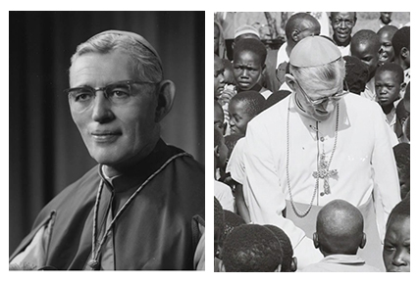

ALTERNATIVE HYMNS

Go Make of All Disciples
God Has Chosen Me by Bernadette Farrell Here I Am, Lord
I Am the Bread of Life
I Receive the Living God
Now Let Us from This Table Rise (TUNE: DUKE STREET) The Church of Christ Cannot Be Bound
The Church of Christ (TUNE: O WALY WALY) To Be Your Presence (TUNE: ENGELBERG)

PRAYER FOR THE YEAR OF MISSION
Lord God, source of all goodness, in your divine Providence you entrusted Blessed Basile Moreau with the task of sending missionaries to spread the light of truth in response to the needs of your universal Church.

We thank you for those faith-filled religious who risked going beyond the borders of every sort to proclaim the good news of the kingdom of God.

Enkindle in us all, members of the family of Holy Cross, a renewed missionary zeal. Grant that we may sow the seeds of faith and be heralds of hope to all peoples, especially the poor, the oppressed, and the marginalized, that you may be known, loved and served.

Through the intercession of Servants of God Flavian Laplante and Vincent McCauley, co-patrons of our Year of Mission, give us the grace to respond generously and wholeheartedly to the urgent call of evangelization.

We make this prayer in the name of Jesus the Lord. Amen.

Acknowledgements
All music used with permission. Reprinted under One License, #A-702876 . All rights reserved. Feel Free to download in the USA.
Excerpts from the English translation of The Roman Missal © 2010, International Commission on English in Liturgy Corporation. All rights reserved.
Excerpts from the English translation from the Liturgy of the Hours © 2010, International Commission on English in Liturgy Corporation. All rights reserved.

